Web Application Development Lab 05 Report
  - Student Name: Vũ Quốc Khánh
Student ID: ITCSIU24039

Exercise 1

Task 1.2
/*
* Click nbfs://nbhost/SystemFileSystem/Templates/Licenses/license-default.txt to change this license
* Click nbfs://nbhost/SystemFileSystem/Templates/Classes/Class.java to edit this template
*/
package model;

import java.sql.Timestamp;

/**
*
* @author Islabre
*/
public class Student {
private int id;
private String studentCode;
private String fullName;
private String email;
private String major;
private Timestamp createdAt;

public Student() {
}

public Student(String studentCode, String fullName, String email, String major) {
this.studentCode = studentCode;
this.fullName = fullName;
this.email = email;
this.major = major;
}

public int getId() {
return id;
}

public void setId(int id) {
this.id = id;
}

public String getStudentCode() {
return studentCode;
}

public void setStudentCode(String studentCode) {
this.studentCode = studentCode;
}

public String getFullName() {
return fullName;
}

public void setFullName(String fullName) {
this.fullName = fullName;
}

public String getEmail() {
return email;
}

public void setEmail(String email) {
this.email = email;
}

public String getMajor() {
return major;
}

public void setMajor(String major) {
this.major = major;
}

public Timestamp getCreatedAt() {
return createdAt;
}

public void setCreatedAt(Timestamp createdAt) {
this.createdAt = createdAt;
}

@Override
public String toString() {
return "Student{" + "id=" + id + ", studentCode=" + studentCode + ", fullName=" + fullName + ", email=" + email + ", major=" + major + '}';
}
}

Task 1.3

Code
/*
* Click nbfs://nbhost/SystemFileSystem/Templates/Licenses/license-default.txt to change this license
* Click nbfs://nbhost/SystemFileSystem/Templates/Classes/Class.java to edit this template
*/
package dao;

import model.Student;
import java.sql.*;
import java.util.ArrayList;
import java.util.List;

/**
*
* @author Islabre
*/
public class StudentDAO {
private final String url = "jdbc:mysql://localhost:3306/student_management";
private final String username = "root";
private final String password = "Q@jaP*96T8xY#2^7&3@7";

// Add this main method to test (remove after testing)
public static void main(String[] args) {
StudentDAO dao = new StudentDAO();
List<Student> students = dao.getAllStudents();
for (Student s : students) {
System.out.println(s);
}
}

private Connection getConnection() throws SQLException {
try {
Class.forName("com.mysql.cj.jdbc.Driver");
return DriverManager.getConnection(this.url, this.username, this.password);
} catch (ClassNotFoundException e) {
throw new Error("Error: MySQL Driver not found");
}
}

public List<Student> getAllStudents() {
Connection conn = null;
PreparedStatement pstmt = null;
ResultSet rs = null;

List<Student> students = new ArrayList<>();

String sql = "SELECT * FROM students ORDER BY id";

try {
conn = getConnection();
pstmt = conn.prepareStatement(sql);
rs = pstmt.executeQuery();

while (rs.next()) {
Student s = new Student(
rs.getString("student_code"),
rs.getString("full_name"),
rs.getString("email"),
rs.getString("major")
);

s.setId(rs.getInt("id"));
s.setCreatedAt(rs.getTimestamp("created_at"));

students.add(s);
}

return students;
} catch (SQLException e) {
throw new Error("Database Error: " + e.getMessage());
} finally {
try {
if (conn != null) conn.close();
if (pstmt != null) pstmt.close();
if (rs != null) rs.close();
} catch (SQLException e) {
e.printStackTrace();
}
}
}
}

Testing Result
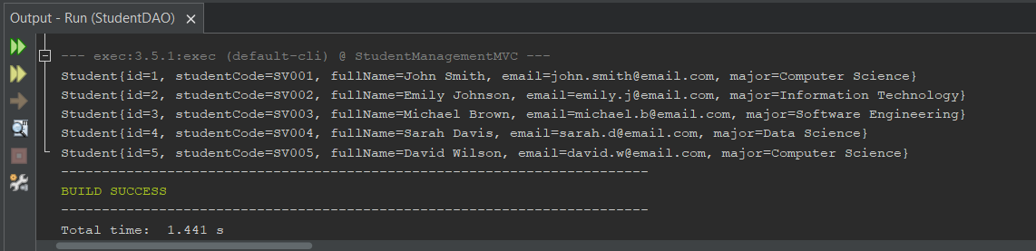

Exercise 2

Task 2.1
/*
* Click nbfs://nbhost/SystemFileSystem/Templates/Licenses/license-default.txt to change this license
* Click nbfs://nbhost/SystemFileSystem/Templates/Classes/Class.java to edit this template
*/
package controller;

import dao.StudentDAO;
import model.Student;

import jakarta.servlet.RequestDispatcher;
import jakarta.servlet.ServletException;
import jakarta.servlet.annotation.WebServlet;
import jakarta.servlet.http.HttpServlet;
import jakarta.servlet.http.HttpServletRequest;
import jakarta.servlet.http.HttpServletResponse;
import java.io.IOException;
import java.util.List;

/**
*
* @author Islabre
*/
@WebServlet("/student")
public class StudentController extends HttpServlet {
private StudentDAO studentDAO;

@Override
public void init() {
this.studentDAO = new StudentDAO();
}

@Override
protected void doGet(HttpServletRequest request, HttpServletResponse response)
throws ServletException, IOException {
String action = request.getParameter("action");

if (action == null) action = "list";

// TODO: Route to appropriate method based on action
switch (action) {
case "list":
listStudents(request, response);
break;
// TODO: Add more cases later
}
}

private void listStudents(HttpServletRequest request, HttpServletResponse response)
throws ServletException, IOException {
List<Student> students = studentDAO.getAllStudents();
request.setAttribute("students", students);

RequestDispatcher dispatcher = request.getRequestDispatcher("/views/student-list.jsp");
dispatcher.forward(request, response);
}
}

Task 2.2
/*
* Click nbfs://nbhost/SystemFileSystem/Templates/Licenses/license-default.txt to change this license
* Click nbfs://nbhost/SystemFileSystem/Templates/Classes/Class.java to edit this template
*/
package controller;

import dao.StudentDAO;
import model.Student;

import jakarta.servlet.RequestDispatcher;
import jakarta.servlet.ServletException;
import jakarta.servlet.annotation.WebServlet;
import jakarta.servlet.http.HttpServlet;
import jakarta.servlet.http.HttpServletRequest;
import jakarta.servlet.http.HttpServletResponse;
import java.io.IOException;
import java.util.List;

/**
*
* @author Islabre
*/
@WebServlet("/student")
public class StudentController extends HttpServlet {
private StudentDAO studentDAO;

@Override
public void init() {
this.studentDAO = new StudentDAO();
}

@Override
protected void doGet(HttpServletRequest request, HttpServletResponse response)
throws ServletException, IOException {
String action = request.getParameter("action");

if (action == null) action = "list";

// TODO: Route to appropriate method based on action
switch (action) {
case "list": listStudents(request, response); break;
case "new": showNewForm(request, response); break;
case "edit": showEditForm(request, response); break;
case "delete": deleteStudent(request, response); break;
}
}

@Override
protected void doPost(HttpServletRequest request, HttpServletResponse response) throws ServletException, IOException {
String action = request.getParameter("action");

switch (action) {
case "insert": insertStudent(request, response); break;
case "update": updateStudent(request, response); break;
}
}

private void listStudents(HttpServletRequest request, HttpServletResponse response)
throws ServletException, IOException {
List<Student> students = studentDAO.getAllStudents();
request.setAttribute("students", students);

RequestDispatcher dispatcher = request.getRequestDispatcher("/views/student-list.jsp");
dispatcher.forward(request, response);
}

private void showNewForm(HttpServletRequest request, HttpServletResponse response)
throws ServletException, IOException {
RequestDispatcher dispatcher = request.getRequestDispatcher("/views/student-form.jsp");
dispatcher.forward(request, response);
}

private void showEditForm(HttpServletRequest request, HttpServletResponse response)
throws ServletException, IOException {
String id = request.getParameter("id");
// TODO: Get student by id and forward as attribute

RequestDispatcher dispatcher = request.getRequestDispatcher("/views/student-form.jsp");
dispatcher.forward(request, response);
}

private void deleteStudent(HttpServletRequest request, HttpServletResponse response)
throws ServletException, IOException {
String id = request.getParameter("id");
// TODO: Delete student by id

RequestDispatcher dispatcher = request.getRequestDispatcher("/views/student-list.jsp");
dispatcher.forward(request, response);
}

private void insertStudent(HttpServletRequest request, HttpServletResponse response)
throws ServletException, IOException {
// TODO: Insert student from POST info

RequestDispatcher dispatcher = request.getRequestDispatcher("/views/student-list.jsp");
dispatcher.forward(request, response);
}

private void updateStudent(HttpServletRequest request, HttpServletResponse response)
throws ServletException, IOException {
// TODO: Update student from POST info

RequestDispatcher dispatcher = request.getRequestDispatcher("/views/student-list.jsp");
dispatcher.forward(request, response);
}
}

Exercise 3

Task 3.1

Code
<%@ page language="java" contentType="text/html; charset=UTF-8" pageEncoding="UTF-8" %>
<%@ taglib uri="http://java.sun.com/jsp/jstl/core" prefix="c" %>
<!DOCTYPE html>
<html>
<head>
<meta charset="UTF-8">
<title>Student List</title>
<style>
table, td, th {
border: 1px solid;
border-collapse: collapse;
}

th, td {
padding: 0.25em;
}

button a {
color: inherit;
text-decoration: none;
}
</style>
</head>
<body>
<h1>Student Management (MVC)</h1>

<c:if test="${not empty param.message}">
<div class="success">${param.message}</div>
</c:if>

<c:if test="${not empty param.error}">
<div class="success">${param.error}</div>
</c:if>

<button>
<a href="student?action=new">
Add Student
</a>
</button>

<table>
<thead>
<tr>
<th>ID</th>
<th>Code</th>
<th>Name</th>
<th>Email</th>
<th>Major</th>
<th>Actions</th>
</tr>
</thead>
<tbody>
<c:forEach var="student" items="${students}">
<tr>
<td>${student.id}</td>
<td>${student.studentCode}</td>
<td>${student.fullName}</td>
<td>${student.email}</td>
<td>${student.major}</td>
<td>
<button>
<a href="student?action=edit&id=${student.id}">
Edit
</a>
</button>

<button>
<a href="student?action=delete&id=${student.id}">
Delete
</a>
</button>
</td>
</tr>
</c:forEach>

<c:if test="${empty students}">
<tr>
<td colspan="6">No students found</td>
</tr>
</c:if>
</tbody>
</table>
</body>
</html>

Result
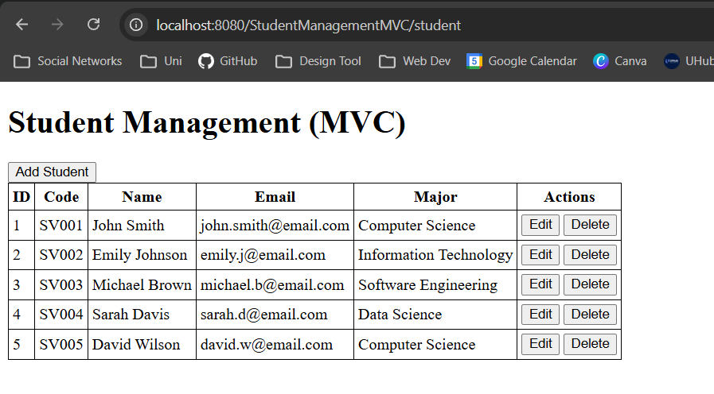

Task 3.2

Code
<%@ page language="java" contentType="text/html; charset=UTF-8" pageEncoding="UTF-8" %>
<%@ taglib uri="http://java.sun.com/jsp/jstl/core" prefix="c" %>
<!DOCTYPE html>
<html>
<head>
<title>
<c:choose>
<c:when test="${student != null}">Edit Student</c:when>
<c:otherwise>Add New Student</c:otherwise>
</c:choose>
</title>
<style>
button a {
color: inherit;
text-decoration: none;
}

input[readonly] {
cursor: not-allowed;
}
</style>
</head>
<body>
<div class="container">
<h1>
<c:choose>
<c:when test="${student != null}">Edit Student</c:when>
<c:otherwise>Add New Student</c:otherwise>
</c:choose>
</h1>

<form action="student" method="POST">
<input type="hidden" name="action" value="${student != null ? 'update' : 'insert'}">

<c:if test="${student != null}">
<input type="hidden" name="id" value="${student.getId()}">
</c:if>

<table>
<tr>
<td>Student Code</td>
<td>
<input type="text" name="studentCode"
value="${student.getStudentCode()}" ${student != null ? 'readonly' : 'required'}>
</td>
</tr>
<tr>
<td>Full Name</td>
<td>
<input type="text" name="fullName" value="${student != null ? student.getFullName() : ''}">
</td>
</tr>
<tr>
<td>Email</td>
<td>
<input type="email" name="email" value="${student != null ? student.getEmail() : ''}">
</td>
</tr>
<tr>
<td>Major</td>
<td>
<input type="text" name="major" value="${student != null ? student.getMajor() : ''}">
</td>
</tr>
<tr>
<td>
<button>
<a href="student?action=list">Cancel</a>
</button>
</td>
<td>
<input type="submit" value="${student != null ? 'Save' : 'Add'}">
</td>
</tr>
</table>
</form>
</div>
</body>
</html>

Result
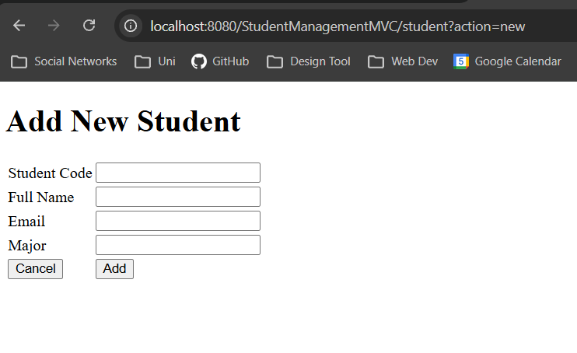

Exercise 4

Task 4.1
/*
* Click nbfs://nbhost/SystemFileSystem/Templates/Licenses/license-default.txt to change this license
* Click nbfs://nbhost/SystemFileSystem/Templates/Classes/Class.java to edit this template
*/
package controller;

import dao.StudentDAO;
import model.Student;

import jakarta.servlet.RequestDispatcher;
import jakarta.servlet.ServletException;
import jakarta.servlet.annotation.WebServlet;
import jakarta.servlet.http.HttpServlet;
import jakarta.servlet.http.HttpServletRequest;
import jakarta.servlet.http.HttpServletResponse;
import java.io.IOException;
import java.util.List;

/**
*
* @author Islabre
*/
@WebServlet("/student")
public class StudentController extends HttpServlet {
private StudentDAO studentDAO;

@Override
public void init() {
this.studentDAO = new StudentDAO();
}

@Override
protected void doGet(HttpServletRequest request, HttpServletResponse response)
throws ServletException, IOException {
String action = request.getParameter("action");

if (action == null) action = "list";

// TODO: Route to appropriate method based on action
switch (action) {
case "list": listStudents(request, response); break;
case "new": showNewForm(request, response); break;
case "edit": showEditForm(request, response); break;
case "delete": deleteStudent(request, response); break;
}
}

@Override
protected void doPost(HttpServletRequest request, HttpServletResponse response) throws ServletException, IOException {
String action = request.getParameter("action");

switch (action) {
case "insert": insertStudent(request, response); break;
case "update": updateStudent(request, response); break;
}
}

private void listStudents(HttpServletRequest request, HttpServletResponse response)
throws ServletException, IOException {
List<Student> students = studentDAO.getAllStudents();
request.setAttribute("students", students);

RequestDispatcher dispatcher = request.getRequestDispatcher("/views/student-list.jsp");
dispatcher.forward(request, response);
}

private void showNewForm(HttpServletRequest request, HttpServletResponse response)
throws ServletException, IOException {
RequestDispatcher dispatcher = request.getRequestDispatcher("/views/student-form.jsp");
dispatcher.forward(request, response);
}

private void showEditForm(HttpServletRequest request, HttpServletResponse response)
throws ServletException, IOException {
String id = request.getParameter("id");
Student student = studentDAO.getStudentById(Integer.valueOf(id));

if (student != null) {
request.setAttribute("student", student);
}

RequestDispatcher dispatcher = request.getRequestDispatcher("/views/student-form.jsp");
dispatcher.forward(request, response);
}

private void deleteStudent(HttpServletRequest request, HttpServletResponse response)
throws ServletException, IOException {
String id = request.getParameter("id");

boolean success = studentDAO.deleteStudent(Integer.valueOf(id));
String message = "";

if (success) {
message = "Student deleted successfully";
response.sendRedirect("student?action=list&message=" + message);
} else {
message = "Error: Failed to delete student";
response.sendRedirect("student?action=list&error=" + message);
}
}

private void insertStudent(HttpServletRequest request, HttpServletResponse response)
throws ServletException, IOException {
String studentCode = request.getParameter("studentCode");
String fullName = request.getParameter("fullName");
String email = request.getParameter("email");
String major = request.getParameter("major");

Student student = new Student(studentCode, fullName, email, major);

boolean success = studentDAO.addStudent(student);
String message = "";

if (success) {
message = "Student added successfully";
response.sendRedirect("student?action=list&message=" + message);
} else {
message = "Error: Failed to add student";
response.sendRedirect("student?action=list&error=" + message);
}
}

private void updateStudent(HttpServletRequest request, HttpServletResponse response)
throws ServletException, IOException {
String id = request.getParameter("id");
String studentCode = request.getParameter("studentCode");
String fullName = request.getParameter("fullName");
String email = request.getParameter("email");
String major = request.getParameter("major");

Student student = new Student(studentCode, fullName, email, major);
student.setId(Integer.valueOf(id));

boolean success = studentDAO.updateStudent(student);
String message = "";

if (success) {
message = "Student updated successfully";
response.sendRedirect("student?action=list&message=" + message);
} else {
message = "Error: Failed to update student";
response.sendRedirect("student?action=list&error=" + message);
}
}
}

Task 4.2
- List:
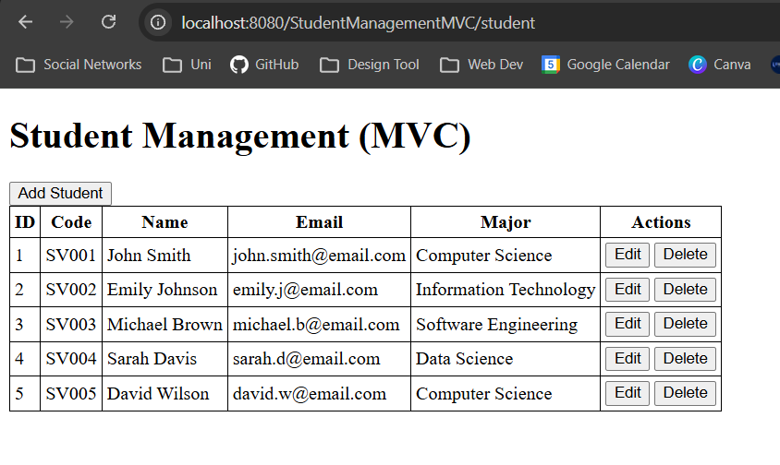
- Add:
- Form with sample data:
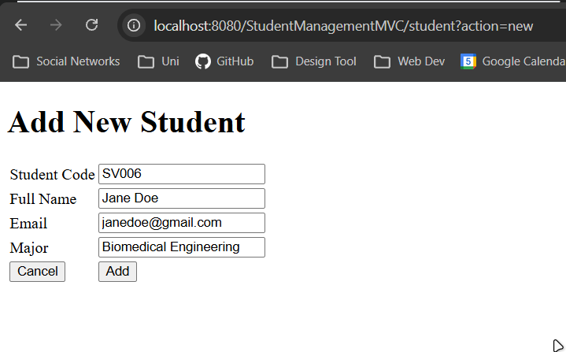
- After submitting:
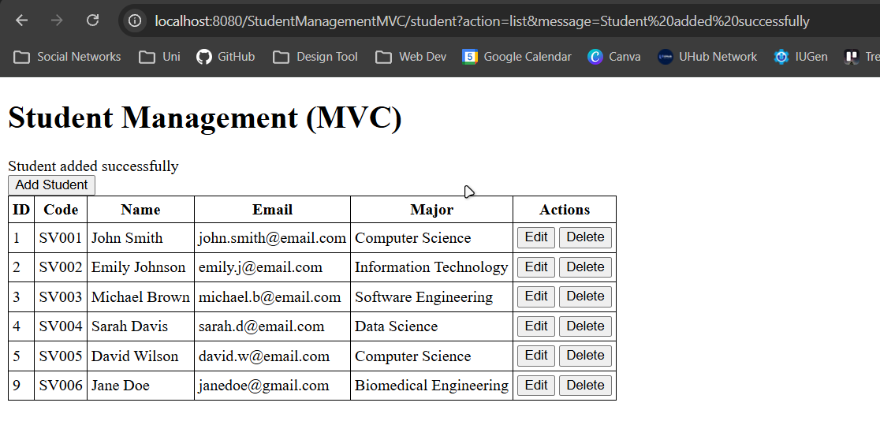
- Edit:
- Editing “Jane Doe” student:
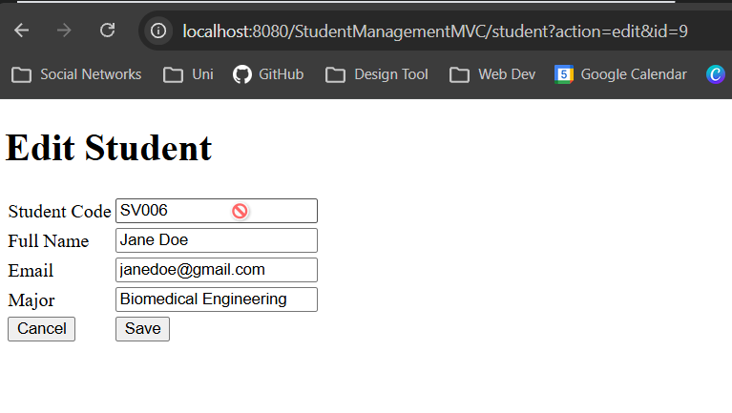
- Modified student data:
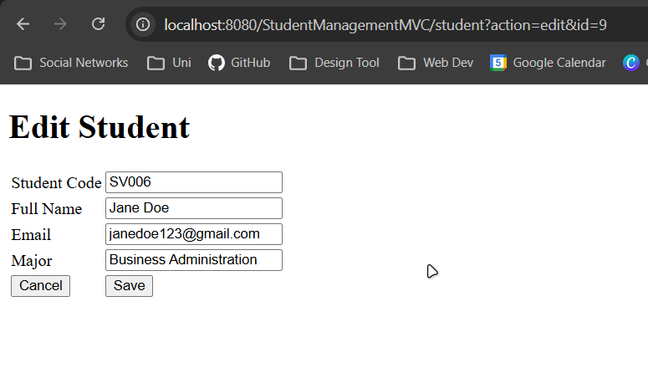
- After submitting:
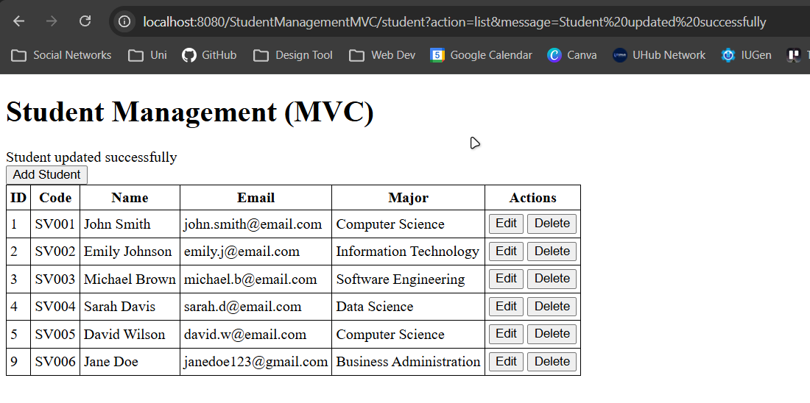
- Delete:
Deleting “Jane Doe” student result:
